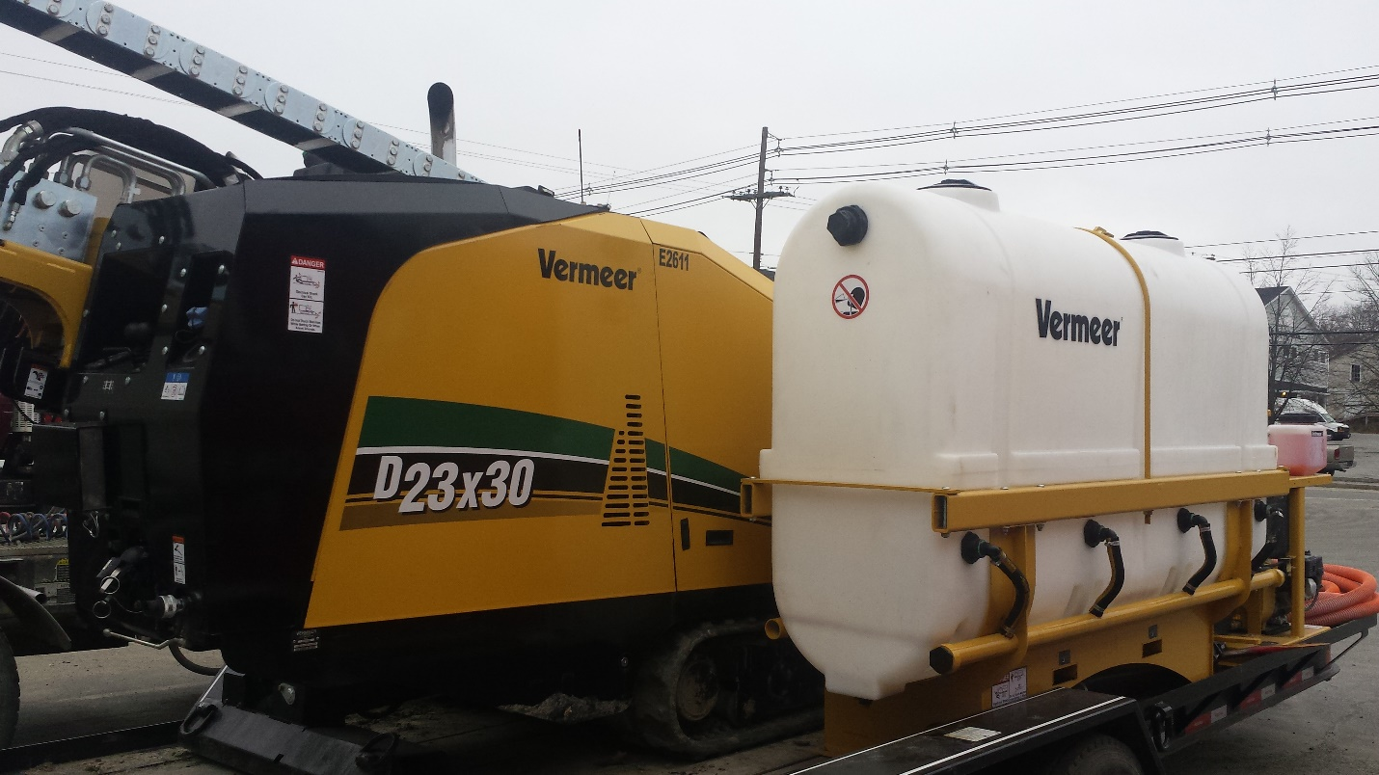

The D23x30 S3 Navigator® horizontal directional drill is one of the quietest drills on the HDD market. With 100 hp (75 kW) Deutz Tier 4 Final or Tier 3 (EU Stage IIIA) engine options, the D23x30 S3 offers speed and power in a short, narrow footprint to help increase productivity when working in compact urban or commercial jobsites. With 24,000 lb (106.8 kN) of thrust and pullback and 3000 ft-lb (4067.5 Nm) of rotational torque.
Features and benefits
- A 99 dB(A) guaranteed sound power level and an operator ear rating of 78.7 dB(A) makes it one of the quietest drills on the market — creating less neighborhood disturbance and enabling easier communication among the crew.
- A carriage speed of 206 ft/min (62.8 m/min) helps operators install more linear feet per day.
- Common control platform from Vermeer assists in operator efficiency and training.
- A 219 rpm rotational speed matches larger drills in the 20,000 to 30,000 lb (89 to 133 kN) class.
- The D23x30 S3 can track up to 3.3 mph (5.3 km/h), helping operators get into position for their next shot more quickly, while the increased tractive effort makes it easier to climb slopes and make sharp turns.

